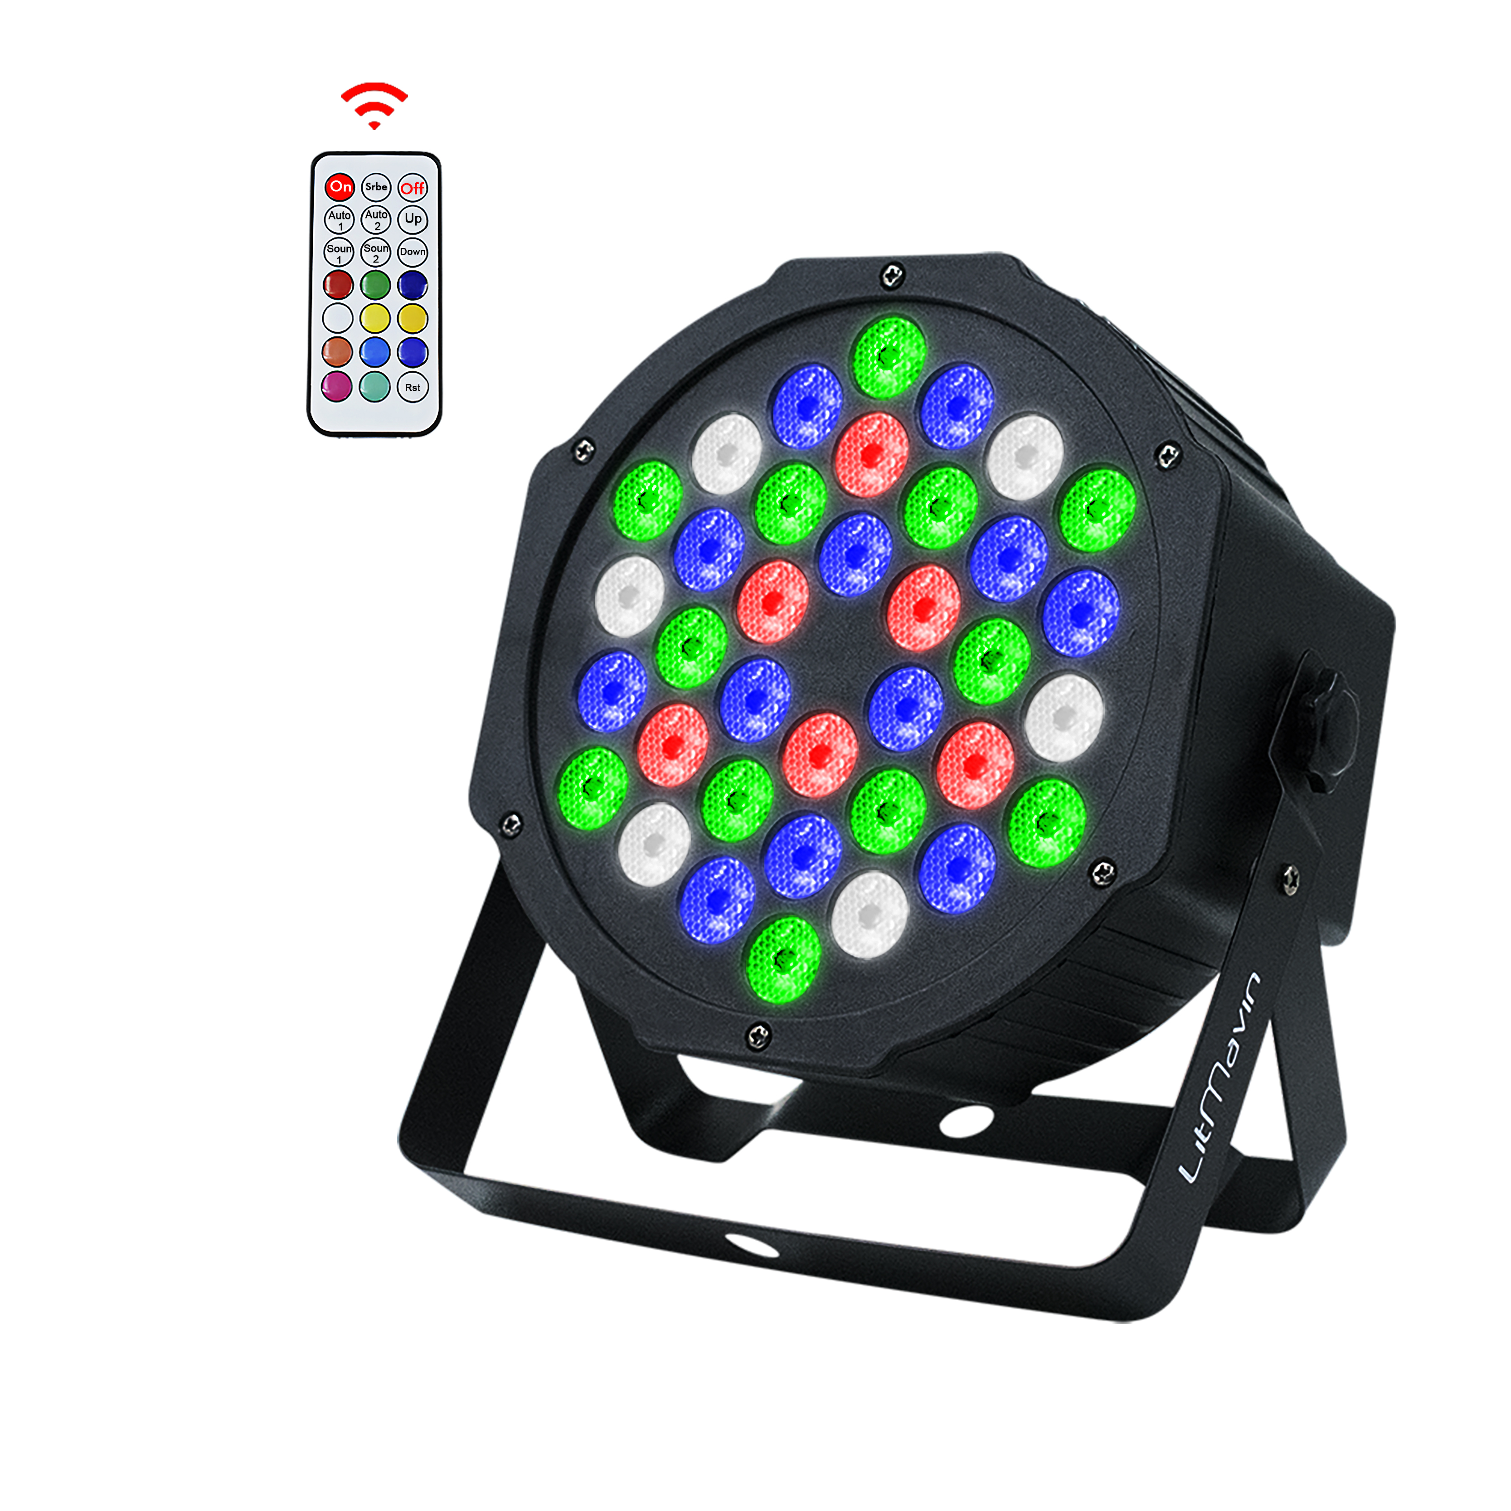

LED DIGITAL DISPLAY 4-COLOR REMOTE CONTROL PAR LIGHT
User’s Manual
Thanks for using our products. For your safety, please read the User’s Manual carefully before your operation.
This Manual includes the important information of installation, operation, safety instruction. Please install and operate as requested in the Manual, meanwhile, please keep the manual for any unexpected requirements
Preface
This Manual includes the important information of installation and operation. In order to make sure the correct and safety installation, operation and maintenance, well know and follow to the instructions of Manual is necessary. Please keep the manual for any unexpected requirement. We will not take any responsibility to the light damage, property loss or body injure which caused by the incorrect installation, operation and maintenance.
NOTICE: The data which inside the Manual maybe changed due to the continuous improvement, and we'll not make another notice. We will keep the right to any specification update during improvement.

Ⅰ. Packing Content
- The Light (1PCS)
- User's Manual(1PCS)
- Remote control
Please confirm if the package is in good condition and contains all the items when you receive the goods . If you meet any problems about the product or operations, please feel free to contact us and we will make your issue right. Email: woshiyewang@outlook.com

II. Safety information
- This product is only operated by adult; please put it where the child can not touch it.
- Please check if the voltage is accordance with the rated power or nor before installation, and please note the total electric circuit load.
- This device is for indoor use only, the light must be kept dry and avoided to use under the Moist, Overheat or Dusty surroundings. If there is any water or other liquid in the product, please cut off the power and contact your supplier.
- Make sure that the power cable does not shrink volume, and the insulation cover of power cable will not be scratched by anything sharp.
- Please cut off power when doesn’t use or before cleaning, maintenance the light.
- The light doesn't include any spare parts for repair. In order to avoid danger, please do not open and change the product structure by yourself.

III. Operation
1.Remote Control Function Description
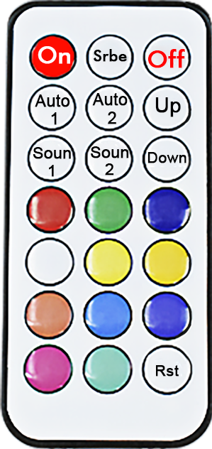
Channel |  | Functions
1 | ON | The remote control to open
2 | Strobe | Strobe  Up, Down Change strobe speed
3 | Off | The remote control off
4 | Auto1 | Auto Run 1
5 | Auto2 | Auto Run 2
6 | Up | Add
7 | Down | Decrease
8 | Soun1 | Sound‐ Active 1
9 | Soun2 | Sound‐ Active 2
10 | R | Red
11 | G | Green
12 | B | Blue
13 | W | White
14 | Colo1 | Mixed color 1
15 | Colo2 | Mixed color 2
16 | Colo3 | Mixed color 3
17 | Colo4 | Mixed color 4
18 | Colo5 | Mixed color 5
19 | Colo6 | Mixed color 6
20 | Colo7 | Mixed color 7
21 | RST | Restore default settings
Auto save after 5 seconds

NOTES:
- There may be a short delay after you press the ON button, please wait for a few seconds before next operation.
- If you selected a single color mode and then you want to select another single color mode, please press the RST button to clear zero first. Otherwise it will become a mixed color.
- You can choose the sound-activated mode through the soun1 or soun2 button. Press the RST button for canceling the sound-activated mode.
- Srbe button is the strobe function. If long press the Srbe button, you can increase the speed of the strobe. Press the RST button for canceling the strobe mode.
- Auto1 and Auto2 button are built-in auto programs. By default, it switches automatically every 5 seconds. In Auto1 or Auto2 mode, you can manually switch the built-in programs by pressing the Up or Down button.
- If the remote control fails unexpectedly, please press the MENU button behind the par light to enter d001 mode.

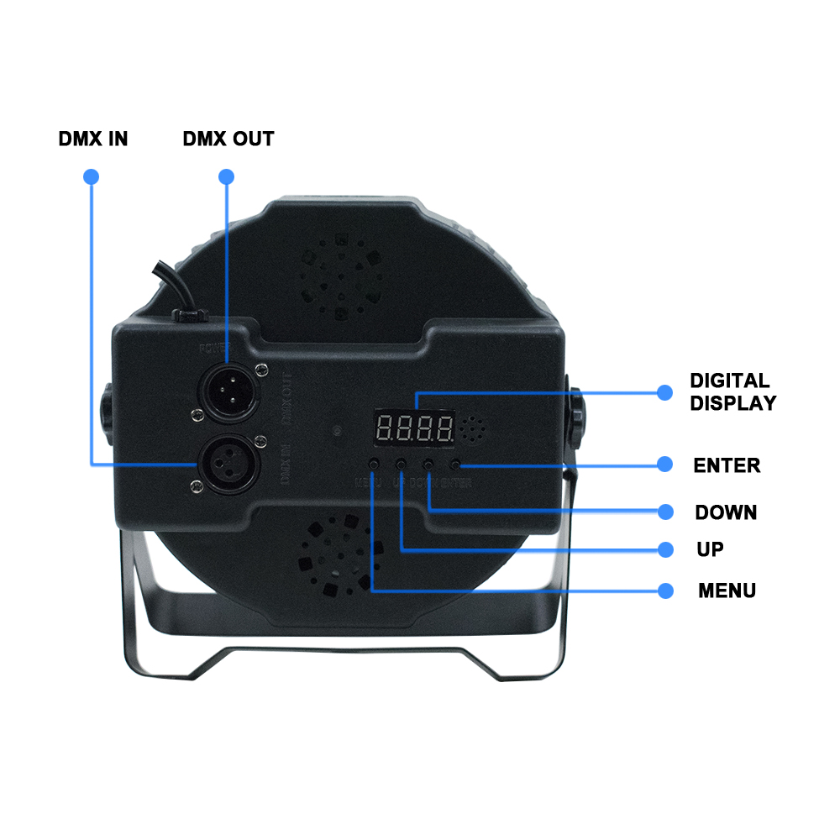
- Graphic explanation：

Operation instructions: Press function Button MENU will cycle out nine different function effects, the first two digits of the digital tube represent the current function (refer to the function table). The last two digits represent the parameters of the address code or speed at which the function is located. Press UP or DOWN to modify its parameter value. Then press ENTER to confirm.

2.LED display function table (all functions are selected and then press ENTER to confirm)
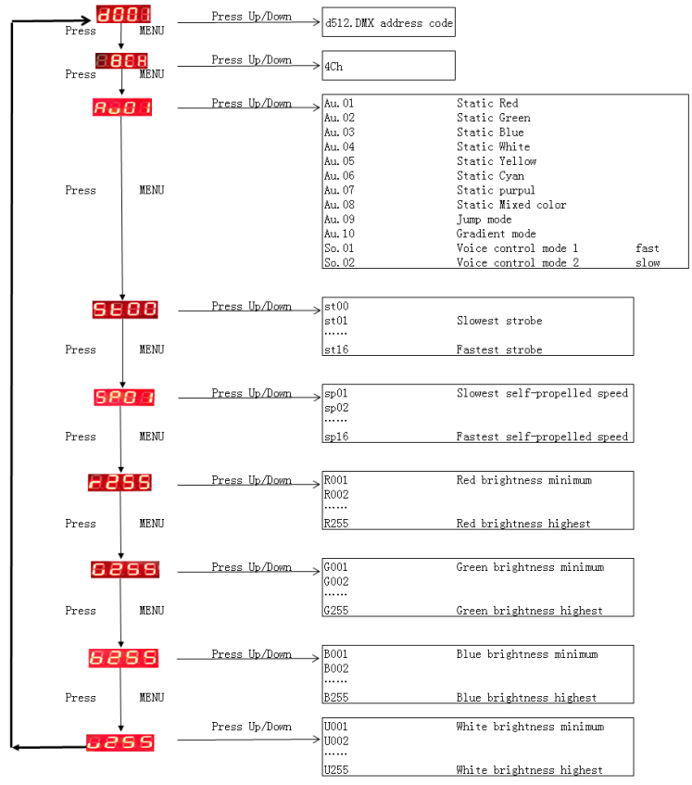

No. | Show | Description
1 | d001 | Address Code（001－512）UP or DOWN button add and subtract address code value
2 | 8ch | 4/8 Channel Control UP or DOWN button add and subtraction modification
3 | Au01 | Au01-Au08 Fixed Color  Au09 Jump Change  Au10 Gradually change  So01 Sound‐Active 1  So02 Sound‐Active 2 UP or DOWN button add and subtraction modification
4 | St00 | St00 No Strobe  St01-St16 Strobe from slow to fast  UP or DOWN button add and subtraction modification
5 | SP01 | SP01-SP16 Auto Run speed from slow to fast  UP or DOWN button add and subtraction modification
6 | R220 | Red selection（000－255） UP or DOWN button modification color selection
7 | G220 | Green selection（000－255） UP or DOWN button modification color selection
8 | B220 | Blue selection（000－255） UP or DOWN button modification color selection
9 | U220 | White selection（000－255） UP or DOWN button modification color selection

3.DMX 512 Channel Description
4 Channel：
Channel | Functions | Description
CH 1 | R Dimming | R Dimming，Linear Dimming，dark to bright
CH 2 | G Dimming | G Dimming，Linear Dimming，dark to bright
CH 3 | B Dimming | B Dimming，Linear Dimming，dark to bright
CH 4 | W Dimming | W Dimming，Linear Dimming，dark to bright
8 Channel：
Channel | Functions | Description
CH 1 | Total Dimming | R;G;B;W Total Dimming，Linear Dimming，dark to bright
CH 2 | R Dimming | R Dimming，Linear Dimming，dark to bright
CH 3 | G Dimming | G Dimming，Linear Dimming，dark to bright
CH 4 | B Dimming | B Dimming，Linear Dimming，dark to bright
CH 5 | W Dimming | W Dimming，Linear Dimming，dark to bright
CH 6 | Total Strobe | R;G;B;W Total Strobe，Slow to Fast
CH 7 | Function Choice | 0－ 3：DMX Channel Control  4－127：8 kinds of fixed color  128－169： Jump Change  170－210： Gradually change  211－229： Sound‐ Active 1  230－255： Sound‐ Active 2
CH 8 | Function Speed | Function Speed ， Slow to Fast

Ⅳ. Cleaning & Maintenance

Clean the product frequently, it can keep the output brightness and extend the product life
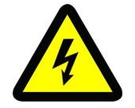
warning：It must be power off before cleaning or
maintenance of the light.

- Product cleaning
- Clean the output acrylic board and product body every 2 weeks, or smoke dust accumulation will weaken the brightness of the light.
- Use soft cloth with water to clean , do not with organic solvent ,such as ethyl alcohol
- Clean the cool fan each month
- Product maintenance
Product maintenance must consider the below terms.
- All screws mounted on the lamp must reliably tightened, check and replace the corroded screws.
- Ensure fixed point for installation without any deformation
- Check if the power cable is damage, and if the insulation layer is wear down.
- To ensure good connection of the various parts of the circuit, and to avoid unnecessary accidents coursed by bad electrical connections, the detailed inspection of the light must be make by the authorized electrical engineer every three months.
V. Technology Parameters
Light source: 36*1W LED (red 6/green 12/blue 12/white 6)
Lighting life: 50,000 hours
Voltage: AC90V-240V/50-60Hz
Rated power: 40W
Out-of-light angle: 25 degrees
Control mode: Sound activation,Auto,Master/slave,DMX512,wireless remote
DMX Channel: 4CH.8CH
Net weight: 1.2/1.4KG
Description: Mini plastic flat pad, plastic shell, adjustable color speed. Feature:New patch leds; 20-50% brighter than the same product, with wireless remote control, machine patch leds, compact, better heat dissipation, longer life.

